NOTICE OF DETERMINATION OF A DEVELOPMENT APPLICATION
Application number | 275/2026/JPZ  PAN-563933
Applicant | Landcom  Level 14 60 Station Street  PARRAMATTA NSW 2150
Description of development | Embellishment and landscaping of open space areas (Items BV2, BV3 and BV5) within the Bella Vista Metro Station Precinct
Property | 1-7 Mawson Avenue, BELLA VISTA NSW 2153  Lot 102 DP 1252968
Determination | Approved  Consent Authority – Sydney Central City Planning Panel
Date of determination
Date from which the consent operates | <DELETE IF THIS IS A DEFERRED COMMENCEMENT CONSENT>  <INSERT DATE>
Date on which the consent lapses | <DELETE AS REQUIRED>  <INSERT DATE>
Approval bodies that have given general terms of approval | <DELETE AS REQUIRED>
Court Case name  LEC Number | <DELETE AS REQUIRED>  <INSERT COURT CASE NAME AND LEC NUMBER>
Building Code of Australia building classification | <DELETE AS REQUIRED>  < INCLUDE BUILDING CLASSIFICATION IF DEVELOPMENT INVOLVES A BUILDING BUT DOES NOT REQUIRE A CONSTRUCTION CERTIFICATE AS PER SECTION 88(1)(G) OF THE EP&A REGULATION >
Independent Planning Commission public hearing | <DELETE AS REQUIRED>  <INSERT DATE OF PUBLIC HEARING IF ONE WAS CONDUCTED>
Under Section 4.18(1) of the Environmental Planning and Assessment (EP&A) Act 1979, notice is given that the above development application has been determined by the granting of consent using the power in Section 4.16(1)(a) of the EP&A Act, subject to the conditions specified in this notice.

Terms and Reasons for Conditions
Under section 88(1)(c) of the EP&A Regulation, the consent authority must provide the terms of all conditions and reasons for imposing the conditions other than the conditions prescribed under section 4.17(11) of the EP&A Act. The terms of the conditions and reasons are set out below.
CROWN DEVELOPMENT
GENERAL CONDITIONS

1. | Approved Plans and Supporting Documentation
1. | The development must be carried out in accordance with the following approved plans and documents, except where the conditions of this consent expressly require otherwise:  In the event of any inconsistency between the approved plans and documents, the approved plans prevail. In the event of any inconsistency with the approved plans and a condition of this consent, the condition prevails.
  Approved plans
  Plan number | Plan title | Drawn by | Date of plan
  2023047-LD-S3-BV-MP001 Rev ‘1’ | Stage 3 Overall Masterplan | Land and Form | 24 April 2026
  LD-S3-BV-RZ-DA000 Rev ‘2’ | Coversheet & Design Statement | Land and Form | 22 April 2026
  LD-S3-BV-RZ-DA001 Rev ‘2’ | Planting Schedules | Land and Form | 22 April 2026
  LD-S3-BV-RZ-DA002 Rev ‘2’ | Legends | Land and Form | 22 April 2026
  LD-S3-BV-RZ-DA010 Rev ‘2’ | Tree Management Plan | Land and Form | 22 April 2026
  LD-S3-BV-RZ-DA100 Rev ‘2’ | Riparian Open Space Masterplan | Land and Form | 22 April 2026
  LD-S3-BV-RZ-DA101 Rev ‘2’ | Riparian Open Space Detail Plan 1 | Land and Form | 22 April 2026
  LD-S3-BV-RZ-DA102 Rev ‘2’ | Riparian Open Space Detail Plan 2 | Land and Form | 22 April 2026
  LD-S3-BV-RZ-DA103 Rev ‘2’ | Riparian Open Space Detail Plan 3 | Land and Form | 22 April 2026
  LD-S3-BV-RZ-DA104 Rev ‘2’ | Riparian Open Space Detail Plan 4 | Land and Form | 22 April 2026
  LD-S3-BV-RZ-DA201 Rev ‘2’ | Riparian Open Space Planting Plan 1 | Land and Form | 22 April 2026
  LD-S3-BV-RZ-DA202 Rev ‘2’ | Riparian Open Space Planting Plan 2 | Land and Form | 22 April 2026
  LD-S3-BV-RZ-DA203 Rev ‘2’ | Riparian Open Space Planting Plan 3 | Land and Form | 22 April 2026
  LD-S3-BV-RZ-DA204 Rev ‘2’ | Riparian Open Space Planting Plan 4 | Land and Form | 22 April 2026
  LD-S3-BV-RZ-DA400 Rev ‘2’ | Riparian Open Space Section 1 | Land and Form | 22 April 2026
  LD-S3-BV-RZ-DA401 Rev ‘2’ | Riparian Open Space Section 2 | Land and Form | 22 April 2026
  LD-S3-BV-RZ-DA402 Rev ‘2’ | Riparian Open Space Section 3 | Land and Form | 22 April 2026
  LD-S3-BV-OP-DA000 Rev ‘1’ | Coversheet & Design Statement | Land and Form | 24 September 2024
  LD-S3-BV-OP-DA001 Rev ‘1’ | Planting Schedule | Land and Form | 24 September 2024
  LD-S3-BV-OP-DA002 Rev ‘1’ | Legends | Land and Form | 24 September 2024
  LD-S3-BV-OP-DA010 Rev ‘1’ | Tree Management Plan | Land and Form | 24 September 2024
  LD-S3-BV-OP-DA100 Rev ‘1’ | Landscape Open Space Masterplan | Land and Form | 24 September 2024
  LD-S3-BV-OP-DA101 Rev ‘1’ | Detail Plan 1 – BV3 | Land and Form | 24 September 2024
  LD-S3-BV-OP-DA102 Rev ‘1’ | Detail Plan 2 – BV2 | Land and Form | 24 September 2024
  LD-S3-BV-OP-DA201 Rev ‘1’ | Planting Plan – BV3 | Land and Form | 24 September 2024
  LD-S3-BV-OP-DA202 Rev ‘1’ | Planting Plan – BV2 | Land and Form | 24 September 2024
  LD-S3-BV-OP-DA400 Rev ‘1’ | BV3 Section 1 | Land and Form | 24 September 2024
  LD-S3-BV-OP-DA401 Rev ‘1’ | BV3 Section 2 | Land and Form | 24 September 2024
  LD-S3-BV-OP-DA402 Rev ‘1’ | BV2 Section 3 | Land and Form | 24 September 2024
  LD-S3-BV-OP-DA403 Rev ‘1’ | BV2 Section 4 | Land and Form | 24 September 2024
  Approved documents
  Document title | Reference | Prepared by | Date of document
  Biodiversity Development Assessment Report – Bella Vista Station Precinct – Stages 3-4 | 40211 Rev ‘02’ | Biosis | 28 April 2026
  Detailed Site Investigation – Bella Vista Station Precinct | 304501564 Rev ‘B’ | Stantec | 2 October 2024
  Bella Vista Station Precinct (Stage 3) Flood Impact and Risk Assessment | Rev ‘4’ – Final | Stantec | 17 April 2026
  Bella Vista Station Precinct – Aboriginal Heritage Impact Statement | 1823 Rev ‘1.0’ | Kelleher Nightingale Consulting | 11 December 2019
  Arboricultural Impact Assessment – Bella Vista Station Precinct – Stages 3 & 4 | G224 Rev ‘B’ | Creative Planning Solutions | 1 May 2026
1. | Condition reason: To ensure all parties are aware of the approved plans and supporting documentation that applies to the development.

2. | Planning Agreement
2. | The obligations under Voluntary Planning Agreement No. 1/2025/VPA (as amended) between The Hills Shire Council, Sydney Metro and Planning Ministerial Corporation dated 29 September 2025 (the ‘Planning Agreement’) must be satisfied in accordance with the terms of the Planning Agreement, including, but not limited to, the registration of the Planning Agreement on the title of the development lots (superlots) and the payment of monetary contributions, dedication of land and completion of works as identified in Schedule 3 of the Planning Agreement.
2. | Condition reason: To contribute towards public infrastructure for the area.
3. | State Significant Development Consent – Concept Development Application
3. | The requirements and conditions of State Significant Development Consent No. SSD-10344 (as amended) for the Bella Vista Station Precinct must be complied with throughout all stages of the development.
3. | Condition reason: To ensure the development is consistent with the Concept State Significant Development Application approval issued for the Bella Vista Station Precinct.
4. | Crown Development – Crown Construction Certification
4. | Before any construction works are carried out, certification of the Crown construction works must be obtained and submitted for Council’s records. The plans and accompanying information submitted for certification must comply with the conditions of this consent.
4. | Condition reason: To ensure the Applicant is aware of Crown development requirements.

5. | Process for Council Endorsement of Legal Documentation
5. | Where an encumbrance on the title of the property is required to be released or amended and Council is listed as the benefiting authority, the relevant release or amendment documentation must be submitted to Council along with payment of the applicable fee as per Council’s Schedule of Fees and Charges. Sufficient time should be allowed for the preparation of a report and the execution of the documents by Council.
5. | Condition reason: To ensure all parties are aware of the process and documentation required to remove an encumbrance on the title of a property where Council is the benefiting authority.

6. | Security Bond Requirements
6. | A security bond may be submitted in lieu of a cash bond. The security bond must:  - Be in favour of The Hills Shire Council;  - Be issued by a financial institution or other accredited underwriter approved by, and in a format acceptable to, Council (for example, a bank guarantee or unconditional insurance undertaking);  - Have no expiry date;  - Reference the development application, condition and matter to which it relates;  - Be equal to the amount required to be paid in accordance with the relevant condition;  - Be itemised if a single security bond is used for multiple items.  Should Council need to uplift the security bond, notice in writing will be forwarded to the Applicant 14 days prior.
6. | Condition reason: For information purposes only.
7. | Section 138 Works – Works within Road Reserve
7. | A Section 138 Roads Act Application, including the payment of application and inspection fees, is required to be lodged with and approved by The Hills Shire Council (being the Roads Authority under the Roads Act 1993) for any works within the road reserve.  Any required engineering plans are to be prepared in accordance with this development consent, State Significant Development Consent No. SSD-10344 (as amended), Bella Vista Station Precinct Design Guidelines, Council’s Design Guidelines – Subdivisions/ Developments, Council’s Works Specifications – Subdivisions/ Developments, Austroads Guidelines and best engineering practice. Before the issue of certification for the Crown subdivision or construction works, a Section 138 Roads Act Approval from Council must be obtained for any works within the road reserve.
7. | Condition reason: To ensure that Council will assess and approve public roads or any other land under the care and control of Council.

8. | Road Opening Permit
8. | Should the subdivision/ development necessitate the installation or upgrading of utility services or any other works on Council land beyond the immediate road frontage of the development site, and these works are not covered by a Section 138 Roads Act Approval issued by Council under this consent, then a separate Road Opening Permit must be applied for and the works inspected by Council’s Maintenance Services team.  The contractor is responsible for instructing sub-contractors or service authority providers of this requirement. Contact Council’s Construction Engineer if it is unclear whether a separate road opening permit is required.
8. | Condition reason: To protect the roads and Council infrastructure.
9. | Protection of Public Infrastructure
9. | Council must be notified of any damage to public infrastructure caused by the development. Adequate protection must be provided prior to work commencing and be maintained during building operations. Any damage caused must be made good, to the satisfaction of Council, before a Crown Completion Certificate can be issued. Public infrastructure includes the road pavement, kerb and gutter, concrete footpaths, drainage structures, utilities and landscaping fronting the site.
9. | Condition reason: To document any damage to public infrastructure during construction and subsequently any damage is to be made good prior to a Crown Completion Certificate.
10. | Protection of Existing Trees and Native Vegetation
10. | Native vegetation (trees and understorey) not identified for removal within this consent is to be kept unless prior consent of Council is obtained.
10. | Condition reason: To ensure retained trees and native vegetation are adequately protected.
11. | Sydney Water Requirements
11. | The development must be undertaken in accordance with the requirements of Sydney Water as detailed in their correspondence (Reference No. 223528, 223185 / CNR-80645 / A99462) dated 23 September 2025 included as Appendix A.
11. | Condition reason: To ensure the development satisfies the requirements of Sydney Metro.

BEFORE CERTIFICATION OF CROWN CONSTRUCTION WORKS
12. | Security Bond – Road Pavement and Public Asset Protection
12. | The consent holder must provide a security bond of $150,000.00 to Council to guarantee the protection of the road pavement and other public assets within the vicinity of the site during construction works. The above amount is calculated at the rate of $142.00 per square metre based on the road frontage of the subject site plus an additional 50m on either side 150m multiplied by the width of the road. A single bond payment with the amount specified above shall be lodged with Council, partial bond payments will not be accepted.  The square metre rate is based on The Hills Shire Council Fees & Charges 2025-2026 which is applicable at the time this consent was issued. Upon lodgement of the bond the amount will be updated to reflect the current schedule of fees and charges that are available on The Hills Shire Council Website.  The bond is refundable upon written application to Council and is subject to all work being restored to Council’s satisfaction. Should the cost of restoring any damage exceed the value of the bond, Council will undertake the works and issue an invoice for the recovery of these costs.  This requirement shall be reflected on the plans and supporting documentation before certification of the Crown subdivision works is issued. The bond must be lodged with Council before certification of the Crown subdivision works or the commencement of any works, whichever precedes first/ earlier.
12. | Condition reason: To allow release of securities and authorise Council to use the security deposit to complete works to its satisfaction.
13. | Engineering Works and Design
13. | The design and construction of the engineering works listed below must be provided generally in accordance with Bella Vista Station Precinct Design Guidelines, Council’s Design Guidelines – Subdivisions/ Developments and Works Specifications – Subdivisions/ Developments.  Engineering works can be classified as either ‘subdivision works’ or ‘building works’.  Works within an existing or proposed public road or works within an existing or proposed public reserve can only be approved, inspected and certified by Council.  Depending on the development type and nature and location of the work the required certificate or approval type will differ. The application form covering these certificates or approvals is available on Council’s website and the application fees payable are included in Council’s Schedule of Fees and Charges.  The concept engineering plans under Development Consent No. 341/2026/JPZ are for development application purposes only and are not to be used for construction:  The design and construction of the engineering works listed below must reflect the concept engineering plans and the conditions of consent. Before certification of the Crown construction works or the commencement of any works, whichever precedes first/earlier, a suitably qualified civil engineer must review the engineering design associated with this development and provide written certification that the design satisfies the following:  - Footpath Verge Formation  The grading, trimming, topsoiling and turfing of the footpath verge fronting the development site is required to ensure a gradient between 2% and 4% falling from the boundary to the top of kerb is provided. This work must include the construction of any retaining walls necessary to ensure complying grades within the footpath verge area. All retaining walls and associated footings must be contained wholly within the subject site. Any necessary adjustment or relocation of services is also required, to the requirements of the relevant service authority. All service pits and lids must match the finished surface level.  - Concrete Cycleway/ Shared Path  A minimum 2.5m wide concrete cycleway/ shared path must be provided in accordance with above documents and approved master plan under State Significant Development Consent No. SSD-10344 (as amended) and the Bella Vista Station Precinct Design Guidelines.  - Gutter Crossings  Gutter crossings to each of the parks/ open space areas are required for maintenance access.  - Disused Layback/ Driveway Removal  All disused laybacks and driveways must be removed and replaced with full kerb and gutter together with the restoration and turfing of the adjoining footpath verge area.  - Service Conduits  Service conduits to each of the open space lots, laid strictly in accordance with the relevant service authority’s requirements, are required. Services must be shown on the engineering drawings.  - Earthworks/ Site Regrading  Earthworks and retaining walls are limited to those locations and heights shown on the concept engineering plans for Development Consent No. 341/2026/JPZ. Where earthworks are not shown on the approved plans for Development Consent No. 341/2026/JPZ, the topsoil within lots must not be disturbed. Retaining walls between lots must be located on the high side lot that is being retained, save the need for easements for support on the low side lot adjacent.  - Stormwater Drainage  All impervious areas must be drained via a pit and pipe system, with connections to a lawful point of discharge, and designed to convey the 1 in 10-year storm event. All surfaces must be graded to ensure drainage toward the lawful point of discharge.  - Stormwater Drainage – Creek Outlets  Piped stormwater outlets/ connections to a natural watercourse must comply with the requirements of Council, the Department of Climate Change, Energy, the Environment and Water (DCCEEW) – Water Group and Sydney Water in the case of stormwater management land.  - Flood Levels  The flood level and extent as approved must be shown on the detailed civil plans prior to certification of the Crown construction works. A Design Compliance Certificate from a qualified civil engineer experienced in flood modelling must be provided to the Crown agency or Certifier where appointed. This certificate should confirm that the proposed development does not impact or alter the flood level.  - General Civil requirements  The construction civil plans and the Operation and Maintenance Plan shall satisfy the following requirements:  - Furniture within 1% AEP zone should be aluminium or recycled plastic. Timber cannot be used.  - Bin bays should be easily accessible preferably via a concrete accessway.  - Where batter more than 1:4 is proposed, low maintenance native planting shall be used.  - All pathways are to be plain or coloured concrete with minimal decorative features.  - All hardstand areas and pathways should be clear of trees.  - Maintenance Bays  The maintenance bays nominated to service the Gross Pollutant Traps (GPTs) along the eastern side of Celebration Drive must be removed and a continuous concrete footpath shall be provided in their place.
  Plan number | Plan title | Drawn By | Date of plan
  304001090-100-C3001 Rev ‘L’ | Locality Plan and Drawing Schedule | Stantec | 12 June 2026
  304001090-100-C3010 Rev ‘L’ | Soil Water Management Layout Plan Sheet 01 | Stantec | 12 June 2026
  304001090-100-C3011 Rev ‘L’ | Soil Water Management Layout Plan Sheet 02 | Stantec | 12 June 2026
  304001090-100-C3012 Rev ‘L’ | Soil Water Management Layout Details | Stantec | 12 June 2026
  304001090-100-C3020 Rev ‘L’ | Bulk Earthworks Layout Plan Sheet 01 | Stantec | 12 June 2026
  304001090-100-C3021 Rev ‘L’ | Bulk Earthworks Layout Plan Sheet 02 | Stantec | 12 June 2026
  304001090-100-C3022 Rev ‘L’ | Bulk Earthworks Sections Sheet 01 | Stantec | 12 June 2026
  304001090-100-C3023 Rev ‘L’ | Bulk Earthworks Sections Sheet 02 | Stantec | 12 June 2026
  304001090-100-C3024 Rev ‘L’ | Bulk Earthworks Sections Sheet 03 | Stantec | 12 June 2026
  304001090-100-C3025 Rev ‘L’ | Bulk Earthworks Sections Sheet 04 | Stantec | 12 June 2026
  304001090-100-C3026 Rev ‘L’ | Retaining Wall Sections Sheet 01 | Stantec | 12 June 2026
  304001090-100-C3027 Rev ‘L’ | Retaining Wall Sections Sheet 02 | Stantec | 12 June 2026
  304001090-100-C3028 Rev ‘L’ | Retaining Wall Details | Stantec | 12 June 2026
  304001090-100-C3030 Rev ‘L’ | General Arrangement Layout Plan Sheet 01 | Stantec | 12 June 2026
  304001090-100-C3031 Rev ‘L’ | General Arrangement Layout Plan Sheet 02 | Stantec | 12 June 2026
  304001090-100-C3040 Rev ‘L’ | Typical Road Cross Sections Sheet 01 | Stantec | 12 June 2026
  304001090-100-C3041 Rev ‘L’ | Typical Road Cross Sections Sheet 02 | Stantec | 12 June 2026
  304001090-100-C3050 Rev ‘L’ | Road Longsection Sheet 01 | Stantec | 12 June 2026
  304001090-100-C3051 Rev ‘L’ | Road Longsection Sheet 02 | Stantec | 12 June 2026
  304001090-100-C3052 Rev ‘L’ | Road Longsection Sheet 03 | Stantec | 12 June 2026
  304001090-100-C3053 Rev ‘L’ | Road Longsection Sheet 04 | Stantec | 12 June 2026
  304001090-100-C3060 Rev ‘L’ | Concept Stormwater Layout Plan Sheet 01 | Stantec | 12 June 2026
  304001090-100-C3061 Rev ‘L’ | Concept Stormwater Layout Plan Sheet 02 | Stantec | 12 June 2026
  304001090-100-C3062 Rev ‘L’ | Typical Stormwater Details | Stantec | 12 June 2026
  304001090-100-C3063 Rev ‘L’ | Stormwater Long Sections Sheet 01 | Stantec | 12 June 2026
  304001090-100-C3064 Rev ‘L’ | Stormwater Long Sections Sheet 02 | Stantec | 12 June 2026
  304001090-100-C3065 Rev ‘L’ | Stormwater Long Sections Sheet 03 | Stantec | 12 June 2026
  304001090-100-C3080 Rev ‘L’ | Services Layout Plan Sheet 01 | Stantec | 12 June 2026
  304001090-100-C3081 Rev ‘L’ | Services Layout Plan Sheet 02 |  | 12 June 2026
  304001090-100-C3090 Rev ‘L’ | Signage and Linemarking Layout Sheet 01 | Stantec | 12 June 2026
  304001090-100-C3091 Rev ‘L’ | Signage and Linemarking Layout Sheet 02 | Stantec | 12 June 2026
  304001090-100-C3100 Rev ‘L’ | External Works Layout Plan Sheet 01 | Stantec | 12 June 2026
  304001090-100-C3101 Rev ‘L’ | External Works Layout Plan Sheet 02 | Stantec | 12 June 2026
13. | Condition reason: To ensure that the engineering design associated with this development has been designed and completed in accordance with Australian Standards, Bella Vista Station Precinct Design Guidelines, Council’s Design Guidelines – Subdivisions/ Developments and Works Specifications – Subdivisions/ Developments.
14. | Preceding Subdivision – Prior Certification of Crown Subdivision Works
14. | This consent is reliant on Development Consent No. 341/2026/JPZ for tree removal, earthworks, and the construction of roads and infrastructure. Before certification of the Crown construction works under the subject consent by the Crown agency or Certifier, or the commencement of any works under this consent (whichever occurs first), certification of the Crown subdivision works under Development Consent No. 341/2026/JPZ must have been issued.
14. | Condition reason: To ensure that the development follows and is consistent with the preceding subdivision.
15. | Detailed Landscaping Plan – Open Space Areas – Bella Vista Metro Precinct
15. | Before certification of the Crown works or the commencement of any works, whichever occurs first, a Detailed Landscaping Plan for the embellishment of the open space areas identified as Item No’s OSE1, OSE2, OSE4 and OSE5 within Voluntary Planning Agreement No. 1/2025/VPA (the ‘Planning Agreement’) must be prepared by a suitably qualified landscape architect and submitted to Council’s Manager – Asset Management, Parks & Waterways for approval.  The Detailed Landscaping Plan must be consistent with Schedule 5 of the Planning Agreement, ‘Kellyville and Bella Vista Station Precinct – Open Space Concept Design’ (Reference No. S18-0057 Issue ‘E’) prepared by Clouston Associates and dated 31 March 2021 and ‘Open Spaces and Streetscapes – Bella Vista & Kellyville Station Precincts’ Report prepared by Land and Form and dated 23 January 2024. The plan must incorporate the following:  - Local Parks BV2 (OSE10) and BV3 (OSE09) must be provided with bins, water fountains and wayfinding signage;  - Local Park BV3 (OSE09) must be provided with bike racks near the playground and shelter areas.  - The Water Wheel Playground Area identified as WT2 within Local Park BV3 (OSE09) is to include accessible and inclusive play equipment.  - Riparian Open Space BV5 (OSE12) must be provided with wayfinding signage and instructional signage for the fitness equipment.  - Timber shall not be used for any landscape architectural elements including fencing, seating, garden edging or recreational structures etc. Galvanised steel, concrete, composites and recycled plastic shall be used as an alternative to reduce ongoing maintenance.  - Light poles are to be connected to the Endeavour Energy street lighting network.  - Open space areas are to be provided with a connection to a water supply for drinking and irrigation purposes.  - The Maintenance Bays nominated to access and service the Gross Pollutants Traps (GPTs) are to be deleted.  The detailed plans must include:  a) site boundaries and dimensions surveyed;  b) north point, and scale (1:200 desirable);  c) existing and proposed levels;  d) all trees, grassed areas, landscape features and main structures on the site (buildings, driveways, walls, fences, paving, storage areas, elements etc);  e) details and specifications of playground equipment and recreational facilities;  f) a schedule of proposed planting, including botanical names, common names, quantities, pot size, expected mature height and staking requirements; and  g) detailed planting plans with individual symbols for planting.
15. | Condition reason: To ensure that the landscaping and embellishment works provide sufficient amenity and facilities for the community.
16. | Flood Protection Requirements
16.
  Structures affected by flooding must be designed and built to ensure they remain structurally sound during potential floods. They must comply with the Flood Planning Level requirements outlined in the Part C Section ‘Flood Controlled Land’ of The Hills Development Control Plan (DCP) 2012 and follow the guidelines.
  The structures must be designed, and the as-built works certified by a structural engineer, to ensure structural soundness during potential floods. The following criteria must be addressed having regard to the depth and velocity of flood water:
  - Hydrostatic pressure;
  - Hydrodynamic pressure;
  - Impact of debris;
  - Buoyancy forces;
  - Saturated ground conditions;
  - Shear stress and scour forces around and downstream of the structure.
  For the purposes of this design the flood levels and associated flood velocities expected to be experienced at the site are:
  - Where the pedestrian path, maintenance vehicle access or other accessible areas are located below the 1% AEP flood level, appropriate signage and safety measures shall be provided to mitigate the safety risk and advise that such areas will be flood affected during major storm events.
  The following additional requirements apply:
  - The design materials and construction of the structures must comply with the principles set out in the publication ‘Reducing Vulnerability of Buildings to Flood Damage – Guidance on Building in Flood Prone Areas’ published by the NSW Government.
  - Structures subject to flooding need to use flood compatible materials to reduce or prevent flood damage. Flood compatible structure components and construction methods should be a combination of strategies included in the design and construction. For more detail, see Schedule B of The Hills DCP 2012. The threshold level should be at least FPL4 (Refer to Table 1 of the DCP).
  - All structures at risk of flooding should be orientated parallel to the direction of the flow to minimise obstruction to these flows.
  - Openings in the structures that are located in line with the direction of flows are to be opened prior to the onset of a flood to allow for unrestricted movement of floodwaters.
  - Note that foundations need to be included in the structural analysis.
  - All service conduits located below FPL3 (Refer to Table 1 of the DCP) are to be made flood compatible and suitable for continuous underwater immersion. Conduits are to be self-draining if subject to flooding.
  - No external storage of materials is to be permitted below FPL3 which reduce flood storage and may cause pollution or be potentially hazardous during any flood.
  - Demonstrate that all structures at risk of flooding can withstand the forces of floodwater, debris, and buoyancy up to and including FPL4.
16. | Condition reason: To ensure that structures are protected against flooding and are structurally sound.
17. | Works on Adjoining Land
17. | Should the engineering works included in the scope of this approval extend into adjoining lands, the consent holder must obtain and submit written consent from any affected adjoining property owners to the Crown agency or Certifier where appointed before certification of the Crown construction works.  These requirements shall be reflected on the plans and supporting documentation before certification of the Crown works is issued.
17. | Condition reason: To ensure adjoining owners are aware of any works on their land and to obtain any access/ consent.
18. | Water Management Act 2000 – Controlled Activity Approval
18. | Before certification of the Crown works or the commencement of any works within 40m from the top of the bank of Elizabeth Macarthur Creek, whichever occurs first, a Controlled Activity Approval under Section 91 of the Water Management Act 2000 must be obtained from the Department of Climate Change, Energy, the Environment and Water (DCCEEW) – Water Group and provided to the Crown agency or Certifier where appointed. Where the obtainment of a Controlled Activity Approval is not required for works within 40m of the watercourse, written evidence of an exemption from DCCEEW – Water Group shall be provided to the Crown agency or Certifier where appointed.
18. | Condition reason: To satisfy the requirements of the Water Management Act 2000.
19. | Erosion and Sediment Control Plan
19. | An Erosion and Sediment Control Plan must be prepared by a suitably qualified person in accordance with the following documents:  - Council’s relevant development control plan,  - the guidelines set out in the NSW Department of Housing manual ‘Managing Urban Stormwater: Soils and Construction’ (the ‘Blue Book’) (as amended from time to time), and  - the ‘Do it Right On-Site, Soil and Water Management for the Construction Industry' (Southern Sydney Regional Organisation of Councils and the Natural Heritage Trust) (as amended from time to time).  The plan is to include a plan of management for the treatment and discharge of water accumulated in open excavations. Water containing suspended solids greater than 50 mg/L shall not be discharged to the stormwater system.  The Erosion and Sediment Control Plan must be submitted to the Crown agency or Certifier where appointed before certification of the Crown subdivision works.
19. | Condition reason: To protect local waterways and the amenity of the local area.

BEFORE WORK COMMENCES
20. | Crown Agency Details
20. | The Crown agency’s name, address, telephone and fax numbers must be submitted to Council in writing two days before works commence. Where a Registered Certifier is appointed to certify the Crown subdivision works, the name, address, telephone and fax numbers of the Certifier must also be submitted to Council in writing two days before works commence.
20. | Condition reason: To ensure that all parties are aware of the Crown agency/ Certifier’s details before works can commence in accordance with the requirements of the Environmental Planning and Assessment Regulation 2021 and Environmental Planning and Assessment (Development Certification and Fire Safety) Regulation 2021.
21. | Erection of Signage – Supervision of Work
21. | Before works commencing on site the Principal Contractor is to ensure a sign is erected in a prominent position displaying the following information:  - The name, address and telephone number of the responsible Crown agency/ Certifier;  - The name and telephone number (including after hours) of the person responsible for carrying out the works;  - That unauthorised entry to the work site is prohibited.  This signage must be maintained while the subdivision work is being carried out and must be removed upon completion.
21. | Condition reason: To address the requirements of the Environmental Planning and Assessment Regulation 2021
22. | Contractor’s Details
22. | Before works commencing on site the Principal contractor carrying out the construction works must have a current public liability insurance policy with an indemnity limit of not less than $20,000,000.00. The policy must indemnify Council from all claims arising from the execution of the works.  A copy of this insurance must be submitted to Council prior to works commencing.
22. | Condition reason: To address requirements under Environmental Planning and Assessment Regulation 2021 and Environmental Planning and Assessment (Development Certification and Fire Safety) Regulation 2021.

23. | Construction Site Management Plan
23. | Prior to commencement of any works on site a Construction Site Management Plan must be prepared and approved by the Crown agency or Certifier where appointed. The plan must include the following matters:  a) The location and materials for protective fencing and hoardings on the perimeter of the site;  b) Provisions for public safety;  c) Pedestrian and vehicular site access points and construction activity zones;  d) Details of construction traffic management including:  i. Proposed truck movements to and from the site;  ii. Estimated frequency of truck movements; and  iii. Measures to ensure pedestrian safety near the site;  e) Details of bulk earthworks to be carried out;  f) The location of site storage areas and sheds;  g) The equipment used to carry out works;  h) The location of a garbage container with a tight-fitting lid;  i) Dust, noise and vibration control measures;  j) The location of temporary toilets;  k) The recommendations of Section 8 of the ‘Bella Vista Station Precinct – Aboriginal Heritage Impact Statement’ (Reference No. 1823 Rev ‘1.0’) prepared by Kelleher Nightingale Consulting dated 11 December 2019; and  l) The protective measures for the preservation of trees on-site and in adjoining public areas including measures in accordance with:  i. AS 4970 ‘Protection of trees on development sites’; and  ii. ‘Arboricultural Impact Assessment – Bella Vista Station Precinct – Stages 3 & 4’ Report (Reference No. G224 Rev ‘B’) prepared by Creative Planning Solutions and dated 1 May 2026.  m) Unexpected finds protocols and guidance on the identification and management of asbestos finds shall be detailed in accordance with the recommendations of the ‘Detailed Site Investigation – Bella Vista Station Precinct’ Report (Reference No. 304501564 Rev ‘B’) prepared by Stantec and dated 2 October 2024.  A copy of the Construction Site Management Plan must be provided for Council’s records prior to the commencement of works. A copy of the plan must be kept onsite at all times while work is being carried out.
23. | Condition reason: To require details of measures that will protect the public, and the surrounding environment, during site works and construction.
 | 24. |  | Toilet Facilities
Before building work commences, toilet facilities are to be provided, at or in the vicinity of the work site on which work involved in the erection or demolition of a building is being carried out, at the rate of one toilet for every 20 persons or part of 20 persons employed at the site.
Each toilet provided:
- must be a standard flushing toilet, and
- must be connected:
- to a public sewer, or
- if connection to a public sewer is not practicable, to an accredited sewage management facility approved by the council, or
- if connection to a public sewer or an accredited sewage management facility is not practicable, to some other sewage management facility approved by the council.
 |  |  | Condition reason: To ensure there are amenities provided to workers on site.
25. |  | Public Infrastructure Inventory Report
Before works commence onsite a Public Infrastructure Inventory Report is to be prepared and submitted to Council recording the condition of all public assets in the direct vicinity of the development site. This includes, but is not limited to, the road fronting the site along with any access route used by heavy vehicles. If uncertainty exists with respect to the necessary scope of this report, it must be clarified with Council before works commence. The report must include:
- Planned construction access and delivery routes; and
- Dated photographic evidence of the condition of all public assets.
 |  | Condition reason: To document the condition of public infrastructure prior to works commencing.
26. | Dilapidation Report
26. | Before any site work commences, a Dilapidation Report must be prepared by a suitably qualified engineer detailing the structural condition of any buildings, structures or works, and public land that adjoins the open space areas.  Where access has not been granted to any adjoining properties to prepare the Dilapidation Report, the report must be based on a survey of what can be observed externally and demonstrate, in writing, to the satisfaction of the Crown agency or Certifier where appointed, that all reasonable steps were taken to obtain access to the adjoining properties.  No less than seven days before any site work commences, adjoining building owner(s) must be provided with a copy of the Dilapidation Report for their property(ies) and a copy of the report(s) must be provided to Council.
26. | Condition reason: To establish and document the structural condition of adjoining properties and public land for comparison as site work progresses and is completed and ensure neighbours and Council are provided with the Dilapidation Report.
27. | Traffic Control Plan
27. | Before the works commence on site a person with the relevant accreditation must complete and approve/sign a Traffic Control Plan relevant to the site. A copy of the plan must be submitted and approved by Council (Traffic team) before being implemented.  A plan that includes full (detour) or partial (temporary traffic signals) width road closure requires separate specific approval from Council. Sufficient time should be allowed for this to occur.
27. | Condition reason: To ensure safe movement of vehicles around/past the site.

28. | Waste Management Plan Requirements
28. | Before site work commences, a Waste Management Plan for the development must be prepared and provided for Council’s records. The plan must be prepared  a) in accordance with  i. the Environment Protection Authority’s Waste Classification Guidelines as in force from time to time, and  ii. a development control plan that provides for waste management that applies to the land on which the work or the clearing of vegetation is carried out, and  b) include the following information—  i. the contact details of the person removing waste,  ii. an estimate of the type and quantity of waste,  iii. whether waste is expected to be reused, recycled or sent to landfill,  iv. the address of the disposal location for waste.  A copy of the Waste Management Plan must be kept on-site at all times while work approved under the development consent is being carried out.
28. | Condition reason: To ensure resource recovery is promoted and local amenity protected during construction.
29. | Erosion and Sediment Controls in Place
29. | Before site work commences, erosion and sediment control measures are to be installed in accordance with the Erosion and Sediment Control Plan. These controls must remain in place until any bare earth has been restabilised in accordance with the NSW Department of Housing manual ‘Managing Urban Stormwater: Soils and Construction’ (the ‘Blue Book’) (as amended from time to time).
29. | Condition reason: To ensure sediment laden runoff and site debris do not impact local stormwater systems and waterways.

30. | Service Authority Consultation
30. | Before the works commence documentary evidence must be submitted to the Crown agency or Certifier where appointed confirming that satisfactory arrangements have been made for:  - The provision of electrical services for the non-residue lots created by the subdivision. This includes the undergrounding of existing overhead services, except where a specific written exemption has been granted by Council.  - The provision of water and sewerage facilities.  - The provision of telecommunication services for the non-residue lots created by the subdivision, typically requiring the installation of pits and pipes complying with the standard specifications of NBN Co current at the time of installation. This includes the undergrounding of existing overhead services, except where a specific written exemption has been granted by Council. The Telecommunications Act 19978 (Cth) specifies where the deployment of optical fibre and the installation of fibre-ready facilities is required.
30. | Condition reason: To ensure appropriate provisions are made for supply of utility services within the subdivision.

31. | Project Ecologist
31. | Before works commence, a Project Ecologist is to be appointed and the following details provided to The Hills Shire Council’s Manager – Environment and Health:  - Name:  - Qualification/s:  - Telephone number/s:  - Email:  If the Project Ecologist is replaced, The Hills Shire Council’s Manager – Environment and Health is to be notified in writing of the reason for the change and the details of the new Project Ecologist within seven days.
31. | Condition reason: To protect vegetation.
32. | Engagement of a Project Arborist
32. | Before site works commence, a Project Arborist (minimum AQF Level 5) is to be appointed and the following details provided to The Hills Shire Council’s Manager – Environment and Health:  - Name:  - Qualification/s:  - Telephone number/s:  - Email:  If the Project Arborist is replaced, Council is to be notified in writing of the reason for the change and the details of the new Project Arborist provided within seven days.
32. | Condition reason: To protect vegetation.
33. | Tree Protection Signage
33. | Before any work begins on the site, a Tree Protection Zone sign must be attached to the tree protection fencing stating “Tree Protection Zone No Access”. The lettering size on the sign shall comply with Australian Standard AS1319. Access to this area can only be authorised by the project arborist or site manager.
33. | Condition reason: To protect trees during the carrying out of site work.
34. | Mulching within Tree Protection Zone
34. | Before any work begins on the site, all areas within the Tree Protection Zones are to be mulched with composted leaf mulch to a depth of 100mm.
34. | Condition reason: To protect trees during the carrying out of site work.
35. | Tree Protection Fencing
35. | Before any work begins on the site, Tree Protection Fencing must be in place around trees or groups of trees nominated for retention. In order of precedence the location of fencing shall be:  a) As per directed by a AQF Level 5 (or greater) Project Arborist; or  b) In accordance with the Tree Protection Zone (TPZ) as calculated under Australian Standard AS4970:2009 ‘Protection of trees on development sites’.  Note: Any variations to the Standards shall be documented and certified by the Project Arborist.  The erection of a minimum 1.8m chain-wire fence to delineate the TPZ is required to stop the following occurring:  - Excavation, installation of services or other works within the TPZ;  - Stockpiling of materials within TPZ;  - Placement of fill within TPZ;  - Parking of vehicles within the TPZ;  - Compaction of soil within the TPZ;  - Cement washout and other chemical or fuel contaminants within TPZ; and  - Damage to tree crown.  Where the provision of the tree protection fencing is impractical due to its proximity to the proposed development footprint, trunk protection shall be erected around nominated trees to avoid accidental damage. The trunk protection shall consist of a layer of carpet underfelt (or similar) wrapped around the trunk, followed by 1.8m metre lengths of softwood timbers (90 x 45mm in section) aligned vertically and spaced evenly around the trunk at 150mm centres (i.e. with a 50mm gap) and secured together with galvanised hoop strap.  All areas within the root protection zone shall be mulched with composted leaf mulch to a depth of no less than 100mm as outlined in the mulching condition of this Consent.  Documentation relating to the implementation of the subject tree protection measures (including certification of supervision) by a Project Arborist shall be provided to Council as outlined in this consent.
35. | Condition reason: To protect trees during the carrying out of site work.
36. | Protection of Existing Trees
36. | Before any work begins on the site, the identified tree/s that are to be retained are to be protected throughout the entire duration of the project. The protection measures should strictly adhere to Australian Standard AS4970:2009 ‘Protection of Trees on Development Sites’ and the ‘Arboricultural Impact Assessment – Bella Vista Station Precinct – Stages 3 & 4’ Report (Reference No. G224 Rev ‘B’) prepared by Creative Planning Solutions and dated 1 May 2026.  The measures under Section 7 of the Arboricultural Impact Assessment are to be implemented, including:  - Stockpiling of materials, placement of fill, parking of vehicles and compaction of soil shall not occur within the designated tree protection zone.  - No installation of services within the tree protection zone shall be undertaken without obtaining prior consent from Council.
36. | Condition reason: To protect trees during the carrying out of site work.

DURING WORKS
37. | Hours of Work
37. | Site work must only be carried out between 7:00am to 5:00pm on Monday to Saturday. No work to be carried out on Sunday or Public Holidays.  The builder/contractor shall be responsible to instruct and control sub-contractors regarding the hours of work.  Site work is not to be carried out outside of these times except where there is an emergency, or for urgent work directed by a police officer or a public authority.
37. | Condition reason: To protect the amenity of the surrounding area.

38. | Construction Noise
38. | During building work, the emission of noise from the construction of the development shall comply with the ‘Interim Construction Noise Guideline’ published by the Department of Environment and Climate Change (July 2009).
38. | Condition reason: To protect residential amenity.
39. | Contamination Assessment
39. | - During works, the recommendations detailed in Section 11.1 of the ‘Detailed Site Investigation – Bella Vista Station Precinct’ Report (Reference No. 304501564 Rev ‘B’) prepared by Stantec and dated 2 October 2024 are to be implemented.  The preparation of a Remedial Action Plan and the remediation of the site is required.  There is to be no disposal of contaminated soil, soil for which the contamination status is unknown, or waste materials on land or under roads either private or roads that will become public land and under the control of Council. The Council will not accept any land that requires on-going management or require any additional consideration, management or precautions if undertaking works in or around the land.
39. | Condition reason: To protect health, safety and the environment
40. | Prohibition of Capped and Contained Contaminated Soil
40. | In the event contaminated soil is identified, there is to be no disposal of contaminated soil, soil for which the contamination status is unknown or waste materials on land or under roads (either private roads or roads that will become public land under the control of Council).  Where there are any inconsistencies between this condition and the ‘Detailed Site Investigation – Bella Vista Station Precinct’ Report (Reference No. 304501564 Rev ‘B’) prepared by Stantec and dated 2 October 2024, this condition takes precedence.
40. | Condition reason: To protect the environment and ensure the site is appropriately remediated and waste is disposed lawfully.
41. | Notification of New Contamination
41. | During subdivision work, ground conditions must be monitored. If any evidence of potential soil contamination is discovered including, the presence of any substance (e.g. chemicals, heavy metals, building materials such as asbestos that may be considered to be above Environment Protection Authority (EPA) or other relevant guidelines in force at the time, and/or likely to present a risk of harm to human health or the environment, works are to immediately cease and a site contamination investigation is to be carried out in accordance with State Environmental Planning Policy (Resilience and Hazards) 2021.  The contamination investigation report is to be submitted to Council’s Manager – Environment and Health for review. If contamination is confirmed, a Remediation Action Plan must be prepared, remediation works carried out as per the recommendations of the report, and a Validation Report completed and submitted. Contaminated waste must be disposed of at a licensed waste facility, unless explicitly approved otherwise. The onsite burial of waste, contaminated soil, or soil material of unknown contamination for which the contaminated status is unknown is prohibited, regardless of the findings of the report.
41. | Condition reason: To ensure controls are in place for contamination management
42. |  | Construction Site Management Plan – Implementation of Plan
During construction, the approved Construction Site Management Plan is to be implemented.

The erosion and sediment control measures must be consistent with ‘Managing Urban Stormwater – Soils and Construction’ (Blue Book) produced by the NSW Department of Housing. Water containing suspended solids greater than 50 mg/L shall not be discharged to the stormwater system.

The plan is to be kept on site at all times and made available upon request.
 |  | Condition reason: To protect the environment.
43. |  | Soil Management
While site work is being carried out, the Crown agency or Certifier where appointed must be satisfied all soil removed from or imported to the site is managed in accordance with the following requirements:

- All excavated material removed from the site must be classified in accordance with the Environment Protection Authority’s (EPA) ‘Waste Classification Guidelines’ before it is disposed of at an approved waste management facility and the classification and the volume of material removed must be reported to the Crown agency or Certifier where appointed;
- All fill material imported to the site must be:
- Virgin Excavated Natural Material as defined in Schedule 1 of the Protection of the Environment Operations Act 1997, or
- a material identified as being subject to a resource recovery exemption by the EPA, or
- a combination of Virgin Excavated Natural Material as defined in Schedule 1 of the Protection of the Environment Operations Act 1997 and a material identified as being subject to a resource recovery exemption by the EPA.

Any waste-derived material the subject of a resource recovery exemption received at the development site must be accompanied by documentation as to the material’s compliance with the exemption conditions and must be provided to the Crown Agency or Certifier where appointed.
 |  | Condition reason: To ensure soil removed from the site is appropriately disposed of and soil imported to the site is not contaminated and is safe for users.
44. | Waste Management
44. | While site work is being carried out:  - all waste management must be undertaken in accordance with the Waste Management Plan, and  - upon disposal of waste, records of the disposal must be compiled and provided to the Crown agency and Council, detailing the following:  - The contact details of the person(s) who removed the waste;  - The waste carrier vehicle registration;  - The date and time of waste collection;  - A description of the waste (type of waste and estimated quantity) and whether the waste is to be reused, recycled or go to landfill;  - The address of the disposal location(s) where the waste was taken;  - The corresponding tip docket/receipt from the site(s) to which the waste is transferred, noting date and time of delivery, description (type and quantity) of waste.  - If waste has been removed from the site under an EPA Resource Recovery Order or Exemption, records in relation to that Order or Exemption must be maintained and provided to the principal certifier and council.
44. | Condition reason: To require records to be provided, during site work, documenting the lawful disposal of waste.
45. | Project Arborist
45. | During site works, the Project Arborist must be on site to supervise any works within the Tree Protection Zone (TPZ) of trees to be retained.  Supervision of the works shall be certified by the Project Arborist and a copy of such certification shall be submitted to the Crown agency and Council within 14 days of completion of the works.
45. | Condition reason: To protect trees during carrying out of site work.

46. | Retention of Trees
46. | While works are being carried out, only trees specifically identified for removal under Development Consent No. 341/2026/JPZ may be removed. All other trees (including neighbouring trees and street trees) are to be retained with remedial work to be carried out in accordance with the Vegetation Management Plan approved under Development Consent No. 341/2026/JPZ and the ‘Arboricultural Impact Assessment – Bella Vista Station Precinct – Stages 3 & 4’ Report (Reference No. G224 Rev ‘B’) prepared by Creative Planning Solutions and dated 1 May 2026.
46. | Condition reason: To ensure retained trees are adequately protected during works.
47. | Vegetation Management Plan – Implementation
47. | While work is being carried out, the commitments and measures set out in the approved Vegetation Management Plan under Development Consent No. 341/2026/JPZ must be implemented at all times. Works associated with the development must not encroach into areas of retained native vegetation and habitat.  A copy of the approved plan is kept on site at all times and made available to council officers upon request.
47. | Condition reason: To protect native vegetation.
48. |  | Biodiversity Management Plan – Implementation
While work is being carried out, the commitments and measures set out in the approved Biodiversity Management Plan under Development Consent No. 341/2026/JPZ must be implemented at all times. Works must not encroach into areas of retained native vegetation and habitat.
A copy of the approved plan is kept on site at all times and made available to council officers upon request.
 |  | Condition reason: To ensure the required biodiversity management measures to avoid and minimise biodiversity impacts are implemented during site works, demolition and construction
49. |  | Site Management – Protection of Vegetation
During all site work, no stockpiling and no activities are to be undertaken within 5 metres of Vegetation proposed for retention or the areas of avoided land.
Any excavated material not used in the construction of the subject works is to be removed from the site and under no circumstances is to be deposited in bushland areas.
 |  | Condition reason: To protect vegetation.
50. | Tree Removal and Fauna Protection
50. | During any tree removal, an experienced wildlife handler is to be present to re-locate any displaced fauna that may be disturbed during this activity. All injured fauna is to be appropriately cared for and released on site when re-habilitated.  Trees must be lopped in such a way that the risk of injury or mortality to fauna is minimised, such as top-down lopping, with lopped sections gently lowered to the ground, or by lowering whole trees to the ground with the ‘grab’ attachment of a machine.  All injured fauna is to be placed into the hands of a wildlife carer (please note only appropriately vaccinated personnel are to handle bats).
50. | Condition reason: To protect fauna.

51. | Protection of Tree Canopy and Ground Protection within Tree Protection Zone
51. | During site works, damage to tree canopies (foliage and branches) is to be avoided when operating excavation machineries, cranes, drilling rigs and similar equipment near tree (s). Under no circumstances shall branches be torn-off by construction equipment. Where there is potential conflict between tree canopy and construction activities, the advice of a Project Arborist must be sought.  In the event of any tree(s) becoming damaged for any reason during the construction period, a Project Arborist shall be engaged to inspect and provide advice on any remedial action to minimise any adverse impact. Such remedial action shall be implemented as soon as practicable and certified by the Project Arborist. The removal of a small portion of the crown (foliage and branches) is generally tolerable provided that the extent of pruning required is within 10% of the total foliage volume of the tree and the removal of branches does not create large wounds or disfigure the natural form and habit of the tree. All pruning cuts must be undertaken in accordance with the Australian Standard AS2373:2007 ‘Pruning of Amenity Trees’.  If any construction access or works is required within the Tree Protection Zone (TPZ) of any tree(s) identified for retention ground protection measures shall be required. Ground protection shall include temporary access for machinery, vehicular and foot traffic within the TPZ of tree(s) on the site and/or on adjoining site(s).  The measures may include a permeable membrane such as geo-textile fabric beneath a layer of mulch or crushed rock below rumble bards as per Clause 4.5.3 ‘Ground protection’ of Australian Standard AS4970:2009. Ground protection shall be installed before any site works and maintained in good condition for the duration of the construction period. On completion of the works, ground protection shall be removed without damage or disturbance to the underlying soil profile.
51. | Condition reason: To protect tree canopy.
52. | Trenching within Tree Protection Zone
52. | Whilst site works are being carried out, any trenching and excavation for construction of footing / piers for retaining walls, installation of drainage, sewerage, irrigation or any other services, and/or for construction of driveways and roads, and/or any ancillary structures shall not occur within the Tree Protection Zone (TPZ) of any trees identified for retention unless under supervision and certification of a suitably qualified AQF Level 5 (or greater) Project Arborist.  Certification of supervision by a Project Arborist must be provided to Crown agency or Certifier where appointed within 14 days of completion of trenching works and/or upon request by Council.  Demolition, construction, or any form of earthworks within the Tree Protection Zone of trees identified for retention shall be carried out so as to avoid damage to the tree roots. Manual excavation shall be carried out under the supervision of the Project Arborist. Manual excavation may include the use of pneumatic and hydraulic tools. Note, mattocks and axes shall not be used.  Where roots within the Tree Protection Zone are exposed by excavation, temporary root protection should be installed to prevent them drying out. This may include jute mesh or hessian sheeting as multiple layers over exposed roots and excavated soil profile, extending to the full depth of the root zone. Root protection sheeting should be pegged in place and kept moist during the period that the root zone is exposed.  Root pruning should be avoided, however where necessary, all cuts shall be clean cuts made with sharp tools such as secateurs, pruners, handsaws, chainsaws or specialised root pruning equipment. Where possible, the roots to be pruned should be located and exposed using minimally destructive techniques such as hand-digging, compressed air or water-jetting, or non-destructive techniques. No roots larger than 40mm in diameter shall be cut without Project Arborist advice and supervision. All root pruning must be done in accordance with Section 9 of Australia Standard AS4373:2007 ‘Pruning of Amenity Trees’.
52. | Condition reason: To protect trees during the carrying out of site work.
53. | Dust Control
53. | During site works, dust suppression techniques must be used to minimise nuisance to surrounding properties. In the absence of any alternative measures, the following measures must be taken to control the emission of dust:  - Dust screens must be erected around the perimeter of the site and be kept in good repair for the duration of the demolition and construction work;  - All dusty surfaces must be wet down and suppressed by means of a fine water spray. Water used for dust suppression must not cause water pollution; and  - All stockpiles of materials that are likely to generate dust must be kept damp or covered.
53. | Condition reason: To prevent the movement of dust outside the boundaries of the development.
54. | Subdivision Earthworks – Lot Topsoil
54. | Where earthworks are not shown on the engineering drawings for Development Consent No. 341/2026/JPZ, the topsoil within the open space lots must not be disturbed. Where earthworks are shown, a 150mm deep layer of topsoil must be provided, suitably compacted and stabilised in accordance with Council’s Works Specification – Subdivisions/ Developments.
54. | Condition reason: To ensure a suitable medium is available to support vegetation growth.
55. | Stockpiles
55. | During site work, stockpiles of topsoil, sand, aggregate or other material capable of being moved by water must be stored clear of any drainage line, easement, natural watercourse, footpath, kerb or roadside.
55. | Condition reason: To protect waterways.
56. | Discovery of Relics and Aboriginal objects
56. | The development must be undertaken in accordance with recommendations of Section 8 of the ‘Bella Vista Station Precinct – Aboriginal Heritage Impact Statement’ (Reference No. 1823 Rev ‘1.0’) prepared by Kelleher Nightingale Consulting dated 11 December 2019.  While site work is being carried out, if a person reasonably suspects a relic or Aboriginal object is discovered:  - The work in the area of the discovery must cease immediately.  - The following must be notified.  i) For a relic – the Heritage Council; or  ii) For an Aboriginal object – the person who is the authority for the protection of Aboriginal objects and Aboriginal places in New South Wales under the National Parks and Wildlife Act 1974, section 85.  Site work may recommence at a time confirmed in writing by:  - For a relic – the Heritage Council; or  - For an Aboriginal object – the person who is the authority for the protection of Aboriginal objects and Aboriginal places in New South Wales under the National Parks and Wildlife Act 1974, section 85
56. | Condition reason: To ensure the protection of objects of potential significance during works
57. | European Sites or Relics
57. | If, during the earthworks, any evidence of a European archaeological site or relic is found, all works on the site are to cease and the NSW Office of Environment and Heritage must be contacted immediately. All relics are to be retained in situ unless otherwise directed by the NSW Office of Environment and Heritage.
57. | Condition reason: To ensure that the developer is aware of the need to stop works and notify the NSW Office of Environment and Heritage should any unidentified sites or relics be found during works.

58. | Critical Stage Inspections – Engineering Works
58. | During construction the Principal Contractor is to ensure a minimum of 24 hours’ notice is provide to Council for any inspections. No works are to commence until the first inspection has been carried out.
58. | Condition reason: To provide adequate notice to Council to arrange inspections to be completed.
59. | Standard of Works
59. | All work must be carried out in accordance with Voluntary Planning Agreement No. 1/2025/VPA (as amended) between The Hills Shire Council, Sydney Metro and Planning Ministerial Corporation dated 29 September 2025 and Council’s Works Specification – Subdivisions/ Developments. The works must include any necessary works required to make the construction effective. All works, including public utility relocation, must incur no cost to Council.
59. | Condition reason: To ensure all works are carried out in accordance with Council’s Works Specification – Subdivisions/ Developments.

ON COMPLETION OF WORKS
60. | Registration of Preceding Subdivision
60. | The registration of the preceding subdivision under Development Consent No. 341/2026/JPZ must occur prior to the completion of the works or the issue of a Crown Completion Certificate.
60. | Condition reason: To ensure that the requirements of the preceding development have been completed and the subdivision registered before a Crown Completion Certificate is issued for the open space areas.
61. | Validation Report
61. | On completion of works or prior to the issue of a Crown Completion Certificate, a Validation Report must be submitted to the Crown agency or Certifier where appointed to address the following:  - The degree of contamination originally present;  - The type of remediation that has been completed; and  - A statement which clearly confirms that the land is unconditionally suitable for recreational/ open space use.  A copy of the Validation Report must be submitted for Council’s records.
61. | Condition reason: To ensure controls are in place for contamination management.
62. | Removal of Waste upon Completion
62. | Upon completion of all site work or prior to the issue of a Crown Completion Certificate, all refuse, spoil and material unsuitable for use on-site must be removed from the site and disposed of in accordance with the approved Waste Management Plan. Written evidence of the waste removal must be provided to the Crown agency or Certifier where appointed.  A copy of the documentation shall also be provided Council’s records.
62. | Condition reason: To ensure waste material is appropriately disposed or satisfactorily stored.
63. | Biodiversity Compliance – Protection of Trees
63. | prior to the issue of a Crown Completion Certificate, a letter from the Project Arborist must be provided to the Crown Agency or Certifier where appointed providing the details demonstrating compliance with the tree protection condition/s of this consent.  The letter is to include is photograph evidence of the tree protection fencing and tree protection measures implemented throughout the development.
63. | Condition reason: Protection of local biodiversity.
64. |  | Completion of Landscape and Tree Works
 |  | On completion of works or prior to the issue of a Crown Completion Certificate, the embellishment and landscaping works shall be completed in accordance with the approved plans and documents and any relevant conditions of this consent.
 |  | Condition reason: To ensure the embellishment and landscaping works have been completed in accordance with the approved landscaping plans.
65. |  | Planting Requirements
On completion of works or prior to the issue of a Crown Completion Certificate, certification from a qualified Landscape Architect must be provided to the Crown agency or Certifier where appointed confirming that the landscaping has been completed in accordance with the approved plans. All trees planted as part of the approved landscape plans are to be minimum 75 litre pot size. All shrubs planted as part of the approved landscape plan are to be minimum 200mm pot size. Groundcovers are to be planted at 5/m². Any species that need substituting requires confirmation from Council.
Parramatta Wattle (Acacia parramattensis) is to be substituted with a longer-lived species that does not readily spread seed or germinate in surrounding areas. Confirmation is required from Council on the proposed species.
 |  | Condition reason: To ensure the approved landscaping works have been completed in accordance with the approved landscaping plans.
66. |  | Post-Construction Dilapidation Report
Before the issue of a Crown Completion Certificate, a Post-Construction Dilapidation Report must be prepared by a suitably qualified engineer, to the satisfaction of the Crown agency or Certifier where appointed. The report must detail whether:

- after comparing the pre-construction dilapidation report to the post-construction dilapidation report required under this condition, there has been any structural damage to any adjoining buildings or structures; and
- where there has been structural damage to any adjoining buildings or structures, whether it is a result of the work approved under this development consent.

Where there is any damage to adjoining properties or structures as a result of the development, the means of rectification shall be nominated for the approval of the Crown agency or Certifier where appointed.

A copy of the Post-Construction Dilapidation Report must be provided to Council and to the relevant adjoining property owner(s).
 |  | Condition reason: To identify any damage to adjoining properties resulting from site work on the development site.
67. |  | Completion of Engineering Works
 |  | A Crown Completion Certificate must not be issued before the completion of all engineering works covered by this consent, in accordance with this consent.
 |  | Condition reason: To ensure all engineering works are completed before the finalisation of the development.
68. | Performance/ Maintenance Security Bond
68. | Before the release of a Crown Completion Certificate the consent holder must submit a performance/ maintenance bond of 5% of the total cost of the works to Council. The bond will be held for a minimum defect liability period of six months from the certified date of completion of the subdivision works. The minimum bond amount is $10,000.00. The bond is refundable upon written application to Council and is subject to a final inspection.
68. | Condition reason: To ensure performance of public assets in accordance with Section 4.17(6) of Environmental Planning and Assessment Act 1979.
69. | Vegetation Management Plan Agreement
69. | Before the issue of a Crown Completion Certificate, a security bond is to be lodged with Council as per the conditions of Development Consent No. 341/2026/JPZ.
69. | Condition reason: To ensure works are carried out in accordance with the approved Vegetation Management Plan.
70. | Public Infrastructure Inventory Report – Post Construction
70. | Before the release of a Crown Completion Certificate an updated Public Infrastructure Inventory Report must be prepared and submitted to Council. The updated report must identify any damage to public assets and the means of rectification for the approval of Council.
70. | Condition reason: To ensure protection and where required suitable remediation of public assets.
71. | Public Asset Creation Summary
71. | A public asset creation summary must be submitted with the Works As Executed (WAE) Plans. A template is available on Council’s website.
71. | Condition reason: To assist in computing the total quantities of public asset/ inventory being handed over to Council.
72. | Works as Executed Plans
72. | Before the issue of the Crown Completion Certificate the Applicant must have completed a Works As Executed (WAE) Plan prepared by a suitably qualified engineer or registered surveyor for all engineering works. This Plan is to be submitted to Council.  The plans must be accompanied by pavement density results, pavement certification, concrete core test results, site fill results, structural certification, CCTV recording, signage details and a public asset creation summary, where relevant.
72. | Condition reason: To ensure works have been completed in accordance with the approved plans and in accordance with Council Standards. Required plans also provide a reference to Council for all works constructed, some of which may be dedicated to Council.
73. | Section 73 Compliance Certificate
73. | Before the issue of a Crown Completion Certificate, a Section 73 Compliance Certificate under the Sydney Water Act 1994 must be obtained from Sydney Water confirming satisfactory arrangements have been made for the provision of water, recycled water and sewer services. Application must be made through an authorised Water Servicing Coordinator. The certificate must refer to this development consent and all of the lots created. This Certificate must be submitted to Council.
73. | Condition reason: To ensure appropriate water, recycled water and/ or sewer facilities are provided when covered by land under the Sydney Water Act 1994
74. | Water Management Act 2000 – Controlled Activity Approval
74. | Before the issue of a Crown Completion Certificate, evidence must be provided to the Crown agency or Certifier where appointed confirming that any works associated with a Controlled Activity Approval under Section 91 of the Water Management Act 2000 have been completed to the satisfaction the Department of Climate Change, Energy, the Environment and Water (DCCEEW) – Water Group. Where the obtainment of a Controlled Activity Approval was not required for works within 40m of the Elizabeth Macarthur Creek, written evidence of an exemption from DCCEEW – Water Group shall be provided to the Crown agency or Certifier where appointed.
74. | Condition reason: To satisfy the requirements of the Water Management Act 2000.

OPERATION AND USE OF THE DEVELOPMENT
75. | Vegetation Management Plan – Ongoing Use
75. | During occupation and ongoing use, all commitments in the approved Vegetation Management Plan under Development Consent No. 341/2026/JPZ must be met.
75. | Condition reason: To protect native vegetation.
76. | Biodiversity Management Plan – Ongoing Use
76. | During ongoing use, all commitments in the approved Biodiversity Management Plan under Development Consent No. 341/2026/JPZ must be met.
76. | Condition reason: To ensure the required biodiversity management measures to avoid and minimise biodiversity impacts are implemented.
77. | Litter Control
77. | During ongoing use of the open space areas, litter and recycling bins shall be provided in accordance with the NSW Environment Protection Authority’s ‘Better Practice Guide for Public Place Recycling’.
77. | Condition reason: To protect the amenity of the local area.

General Advisory Notes

This consent contains the conditions imposed by the consent authority which are to be complied with when carrying out the approved development. However, this consent is not an exhaustive list of all obligations which may relate to the carrying out of the development under the EP&A Act, EP&A Regulation and other legislation. Some of these additional obligations are set out in the Conditions of development consent: advisory notes - https://www.thehills.nsw.gov.au/Council/Fact-Sheet-Directory/Fact-Sheets-Development-Application-Process.

The consent should be read together with the Conditions of development consent: advisory notes to ensure the development is carried out lawfully.

The approved development must be carried out in accordance with the conditions of this consent. It is an offence under the EP&A Act to carry out development that is not in accordance with this consent.

A document referred to in this consent is taken to be a reference to the version of that document which applies at the date the consent is issued, unless otherwise stated in the conditions of this consent.

Appendix A – Sydney Water Requirements
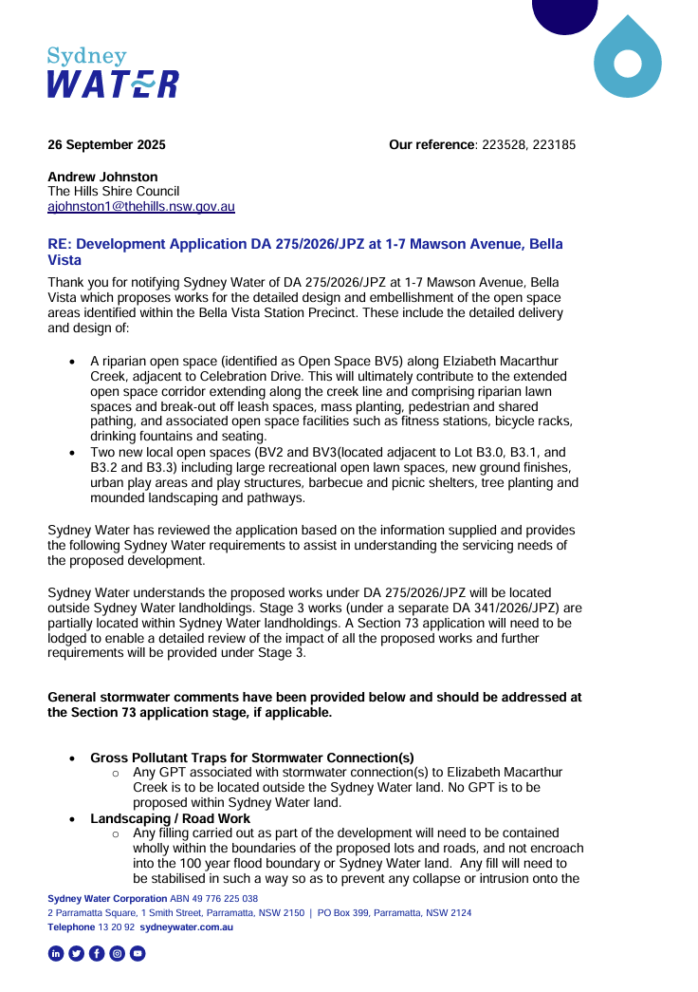

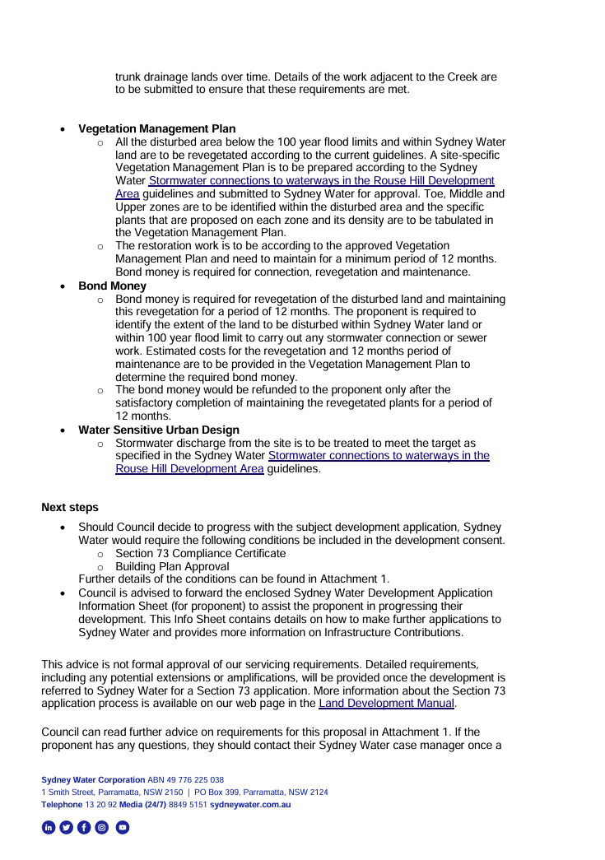

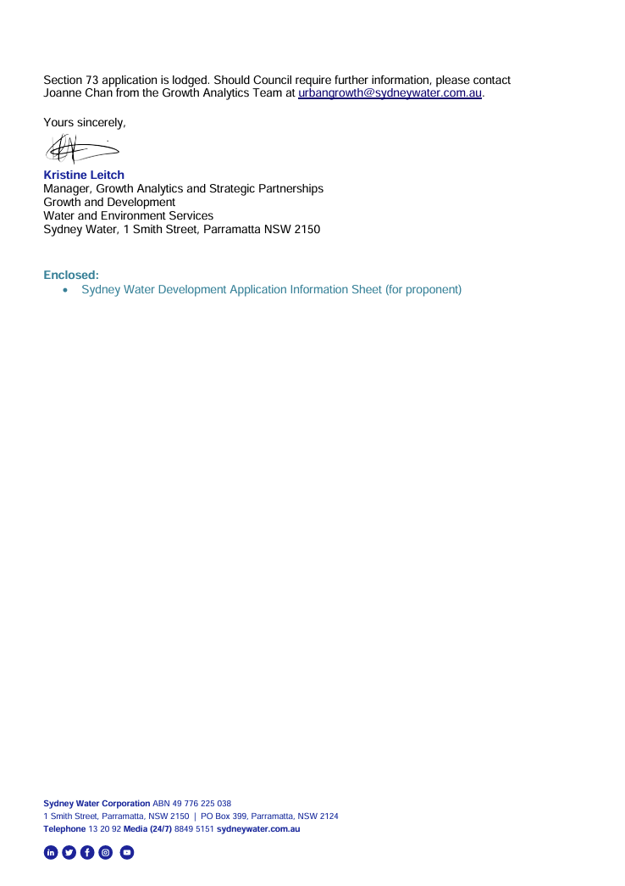

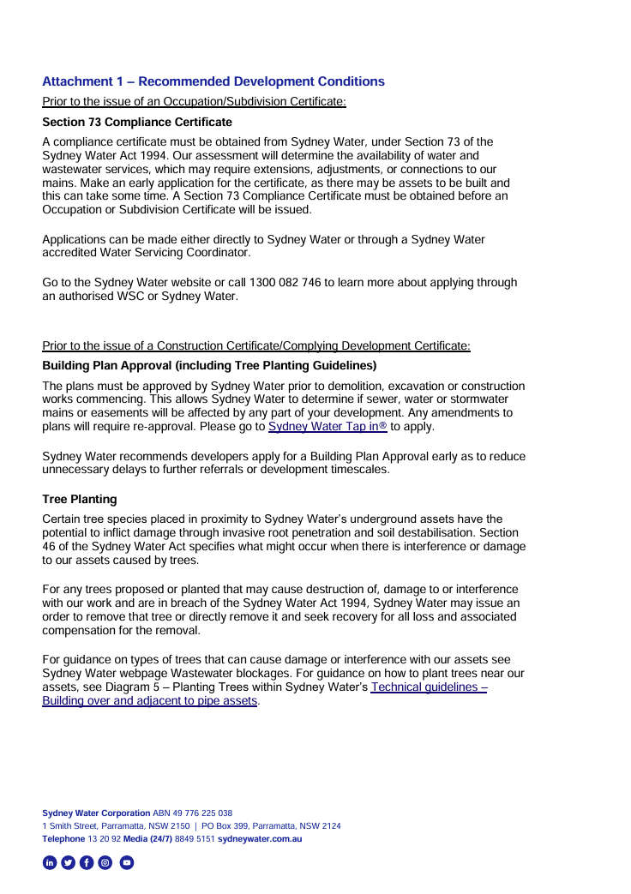

Dictionary
The following terms have the following meanings for the purpose of this determination (except where the context clearly indicates otherwise):
Approved plans and documents means the plans and documents endorsed by the consent authority, a copy of which is included in this notice of determination.
AS means Australian Standard published by Standards Australia International Limited and means the current standard which applies at the time the consent is issued.
Building work means any physical activity involved in the erection of a building.
Certifier means a council or a person that is registered to carry out certification work under the Building and Development Certifiers Act 2018.
Construction certificate means a certificate to the effect that building work completed in accordance with specified plans and specifications or standards will comply with the requirements of the EP&A Regulation and Environmental Planning and Assessment (Development Certification and Fire Safety) Regulation 2021.
Council means The Hills Shire Council.
Court means the Land and Environment Court of NSW.
EPA means the NSW Environment Protection Authority.
EP&A Act means the Environmental Planning and Assessment Act 1979.
EP&A Regulation means the Environmental Planning and Assessment Regulation 2021.
Independent Planning Commission means Independent Planning Commission of New South Wales constituted by section 2.7 of the EP&A Act.
Local planning panel means The Hills Local Planning Panel.
Occupation certificate means a certificate that authorises the occupation and use of a new building or a change of building use for an existing building in accordance with this consent.
Principal certifier means the certifier appointed as the principal certifier for building work or subdivision work under section 6.6(1) or 6.12(1) of the EP&A Act respectively.
Site work means any work that is physically carried out on the land to which the development the subject of this development consent is to be carried out, including but not limited to building work, subdivision work, demolition work, clearing of vegetation or remediation work.
Stormwater drainage system means all works and facilities relating to:
the collection of stormwater,
the reuse of stormwater,
the detention of stormwater,
the controlled release of stormwater, and
connections to easements and public stormwater systems.
Strata certificate means a certificate in the approved form issued under Part 4 of the Strata Schemes Development Act 2015 that authorises the registration of a strata plan, strata plan of subdivision or notice of conversion.
Subdivision certificate means a certificate that authorises the registration of a plan of subdivision under Part 23 of the Conveyancing Act 1919.
Subdivision works certificate means a certificate to the effect that subdivision work completed in accordance with specified plans and specifications will comply with the requirements of the EP&A Regulation.
Sydney district or regional planning panel means Sydney Central City Planning Panel.

